TASK1:
import java.util.*;

interface PerformOperation {
boolean check(int a);
}

public class Solution {

public static PerformOperation isOdd() {
return n -> n % 2 != 0;
}

public static PerformOperation isPrime() {
return n -> {
if (n < 2) {
return false;
}

for (int i = 2; i * i <= n; i++) {
if (n % i == 0) {
return false;
}
}

return true;
};
}

public static PerformOperation isPalindrome() {
return n -> {
int original = n;
int reversed = 0;

while (n != 0) {
reversed = reversed * 10 + n % 10;
n /= 10;
}

return original == reversed;
};
}

public static void main(String[] args) {
Scanner sc = new Scanner(System.in);

int T = sc.nextInt();

while (T-- > 0) {
int condition = sc.nextInt();
int number = sc.nextInt();

PerformOperation operation;

if (condition == 1) {
operation = isOdd();
System.out.println(operation.check(number) ? "ODD" : "EVEN");
}
else if (condition == 2) {
operation = isPrime();
System.out.println(operation.check(number) ? "PRIME" : "COMPOSITE");
}
else {
operation = isPalindrome();
System.out.println(operation.check(number) ? "PALINDROME" : "NOT PALINDROME");
}
}

sc.close();
}
}
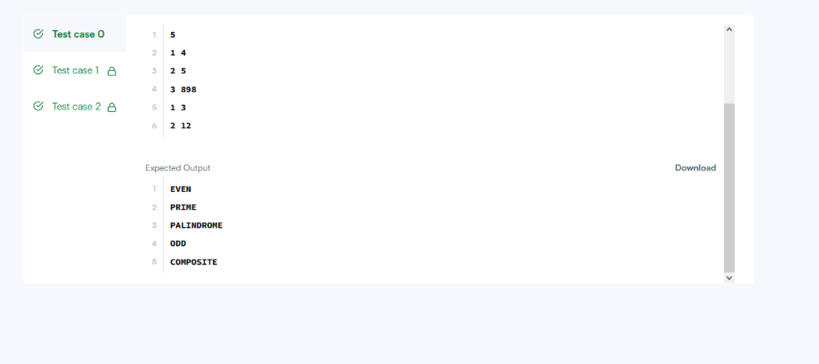

TASK2:
import java.util.*;

class Player {
String name;
int score;

Player(String name, int score) {
this.name = name;
this.score = score;
}
}

class Checker implements Comparator<Player> {

@Override
public int compare(Player a, Player b) {
if (a.score != b.score) {
return b.score - a.score;
}

return a.name.compareTo(b.name);
}
}

public class Solution {
public static void main(String[] args) {
Scanner sc = new Scanner(System.in);

int n = sc.nextInt();
Player[] players = new Player[n];

for (int i = 0; i < n; i++) {
String name = sc.next();
int score = sc.nextInt();
players[i] = new Player(name, score);
}

Arrays.sort(players, new Checker());

for (Player p : players) {
System.out.println(p.name + " " + p.score);
}

sc.close();
}
}

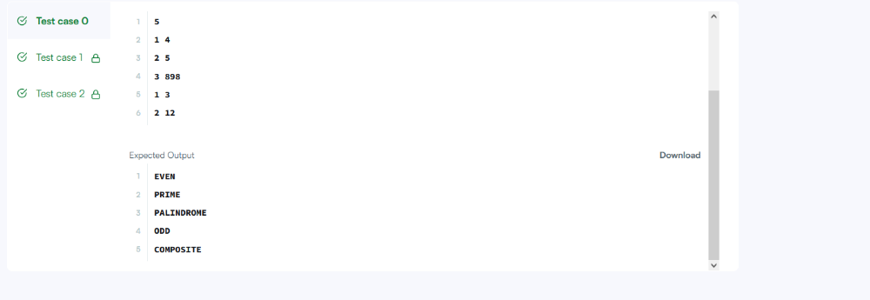

TASK3:
import java.util.*;

class Student {
private int id;
private String fname;
private double cgpa;

public Student(int id, String fname, double cgpa) {
this.id = id;
this.fname = fname;
this.cgpa = cgpa;
}

public int getId() {
return id;
}

public String getFname() {
return fname;
}

public double getCgpa() {
return cgpa;
}
}

class StudentComparator implements Comparator<Student> {

@Override
public int compare(Student a, Student b) {

if (a.getCgpa() != b.getCgpa()) {
return Double.compare(b.getCgpa(), a.getCgpa());
}

int nameCompare = a.getFname().compareTo(b.getFname());

if (nameCompare != 0) {
return nameCompare;
}

return Integer.compare(a.getId(), b.getId());
}
}

public class Solution {

public static void main(String[] args) {

Scanner sc = new Scanner(System.in);

int n = sc.nextInt();

List<Student> students = new ArrayList<>();

for (int i = 0; i < n; i++) {
int id = sc.nextInt();
String name = sc.next();
double cgpa = sc.nextDouble();

students.add(new Student(id, name, cgpa));
}

Collections.sort(students, new StudentComparator());

for (Student student : students) {
System.out.println(student.getFname());
}

sc.close();
}
}

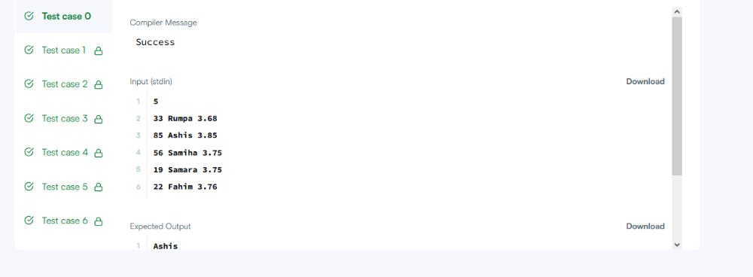

TASK4:
class Solution {
public int[] runningSum(int[] nums) {
int sum = 0;

for (int i = 0; i < nums.length; i++) {
sum += nums[i];
nums[i] = sum;
}

return nums;
}
}
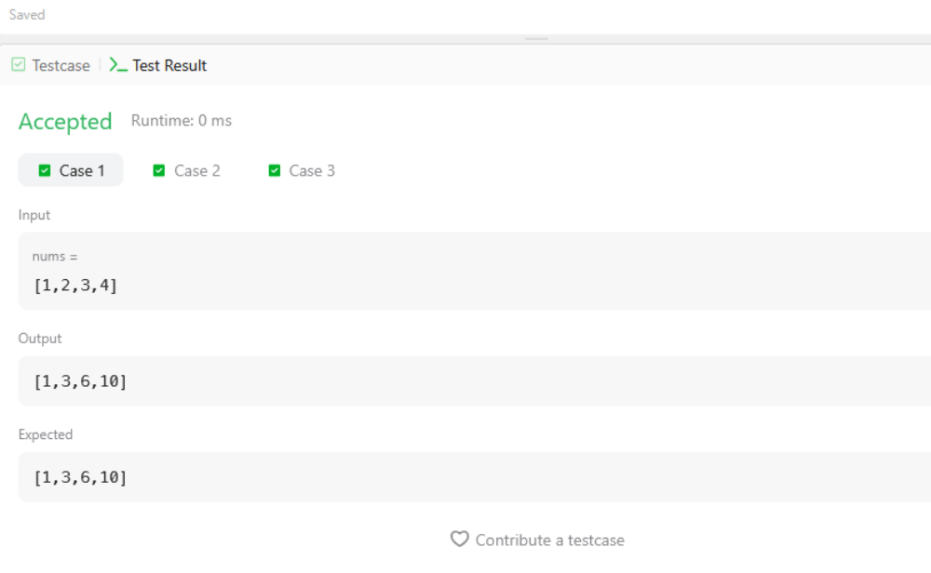

TASK5:
class Solution {
public int maximumWealth(int[][] accounts) {
int maxWealth = 0;

for (int i = 0; i < accounts.length; i++) {
int wealth = 0;

for (int j = 0; j < accounts[i].length; j++) {
wealth += accounts[i][j];
}

maxWealth = Math.max(maxWealth, wealth);
}

return maxWealth;
}
}

